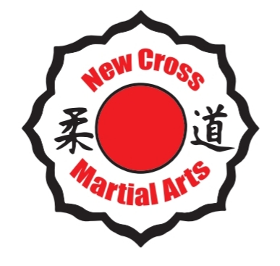 New Cross Martial Arts
Neil Bartholomew (CEO) Brooke Powell (Coach) Cole Bartholomew(Coach)
Tel: 07821 679 058 Tel: 07949 346 926 Tel: 07958 435 464
Email: info@newcrossmartialarts.com

@NewCrossMartialArts _newcrossmartialarts_

Judo
Dear Parents and Careers,

We are pleased to announce that New Cross Martial Arts will be continuing to
run a Judo after school club for our children to attend.

Children will be learning a Japanese martial art and Olympic sport in a fun and exciting way learning Discipline, Self Control and Respect. By children learning the fundamental principles of Judo will improve fitness, flexibility, co-ordination, strength and also self confidence.
Children will take part in regular grading’s to gain their belts to progress through the ranks. New Cross Martial Arts also offer and run Judo competitions both national and International which children will be able to participate in.

Judo sessions will run ever Friday afterschool 3:30pm – 4:30pm.

Start & Finish Date: Friday 17th January – Friday 27th March

Price: £55 (payment is required in advance per full term)

Payment Deadline: Friday 17th January 2020
All fees must be paid by the deadline above. Your child will not be allowed to attend any sessions after deadline date. Due to a long waiting list places are now offered on a first come first served basis throughout the school
NO EXCEPTIONS.

NO PAYMENTS TO SCHOOL OFFICE
MONEY MUST BE PAID DIRECTLY TO JUDO COACHES AND NOT TO SCHOOL OFFICE OR YOUR CHILD. WE HOLD NO RESPONSIBILITY FOR ANY MISSING PAYMENTS SHOULD YOU NOT FOLLOW THIS REQUEST.

Oasis Putney Academy Primary School Registration Form

Child’s (Full) Name………………………………………………..(please print clearly)

Childs Class ………………………………………………….

Does your child have any medical / special needs that we should be aware of?

..............................................................................................................

Parental contact details – (please print clearly)

Parent/Carer Name……………………………………………………………….

Telephone Number……………………………………………………………

Email ……………………………………………………………………………………..

I wish to be contacted regarding renewals and promotions

I give permission for

.............................................................. Relationship to child ..............................................................
.............................................................. Relationship to child ..............................................................
.............................................................. Relationship to child ..............................................................
.............................................................. Relationship to child ..............................................................
to collect my child.

Please note that children will not be dismissed to anyone other than Parents / Carers stated above. If circumstances change please contact coaches directly.

Signed……………………………………………………………………………………

Please return form with the correct payment only to one of the judo coaches (NO CHANGE WILL BE GIVEN OR HELD AS CREDIT)
(Staff and instructors do not carry cash)

Cash or card payments only (Card payments can also be taken over the telephone please call any of the numbers stated at the top of the letter)
METHOD OF PAYMENT (please tick)
CASH

CARD PAYMENT Date paid ………………………………….
PLEASE NOTE: Coaches will only be available to discuss any issues, concerns and collect payments at 4:30 – 5:00pm on training days. Coaches will not be able to leave their sessions to speak to parents/ carers once class has started.

