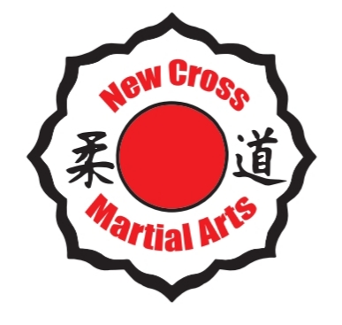 New Cross Martial Arts
Neil Bartholomew (CEO) Brooke Powell (Coach) Cole Bartholomew(Coach)
Tel: 07821 679 058 Tel: 07949 346 926 Tel: 07958 435 464
Email: info@newcrossmartialarts.com

@NewCrossMartialArts _newcrossmartialarts_

Muay Thai Kickboxing

Dear Parents and Careers,

We are pleased to announce that New Cross Martial Arts will be offering a Muay Thai Kickboxing Breakfast club for our children to attend.

Children will learn a Thai Martial Art & Combat Sport in a fun and exciting way. Learning authentic Thai techniques, Using Punches, Kicks, Knees and Elbows. Children will learn offensive and defensive fighting techniques. Following a suitable course in Muay Thai training, children will benefit enormously from the physical and mental improvements.
Muay Thai will improve a child’s self-confidence and self-awareness. As well as keeping them quick, agile, healthy and strong.

Muay Thai sessions will run every Tuesday morning 8:00 – 9:00am

Start & Finish Date: Tuesday 14th January – Tuesday 24th March 2020

Price: £55 (payment is required in advance per full term)

Payment Deadline: Tuesday 14th January 2020

All fees must be paid by the deadline above. Your child will not be allowed to attend any sessions after deadline date. Due to a long waiting list places are now offered on a first come first served basis throughout the school
NO EXCEPTIONS.

NO PAYMENTS TO SCHOOL OFFICE
MONEY MUST BE PAID DIRECTLY TO JUDO COACHES AND NOT TO SCHOOL OFFICE OR YOUR CHILD. WE HOLD NO RESPONSIBILITY FOR ANY MISSING PAYMENTS SHOULD YOU NOT FOLLOW THIS REQUEST

Oasis Putney Academy Primary School Registration Form – Muay Thai

Child’s (Full) Name………………………………………………..(please print clearly)

Childs Class ………………………………………………….

Does your child have any medical / special needs that we should be aware of?

..............................................................................................................

Parental contact details – (please print clearly)

Parent/Carer Name……………………………………………………………….

Telephone Number……………………………………………………………

Email ……………………………………………………………………………………..

I wish to be contacted regarding renewals and promotions

Signed……………………………………………………………………………………

Please return form with the correct payment only to one of the coaches (NO CHANGE WILL BE GIVEN OR HELD AS CREDIT)
(Staff and instructors do not carry cash)

Cash or card payments only (Card payments can also be taken over the telephone please call any of the numbers stated at the top of the letter)

METHOD OF PAYMENT (please tick)

CASH

CARD PAYMENT Date paid ………………………………….

PLEASE NOTE: Coaches will only be available to discuss any issues, concerns and collect payments on training days. Coaches will not be able to leave their sessions to speak to parents/ carers once class has started.

